**Part 1- One Bit Half Adder**

1)

|  |  |  |  |
| --- | --- | --- | --- |
| **A** | **B** | **Sum** | **Carry out (Cout)** |
| 0 | 0 | 0 | 0 |
| 0 | 1 | 1 | 0 |
| 1 | 0 | 1 | 0 |
| 1 | 1 | 0 | 1 |

2)

Sum= A Xor B

Cout= A•B

3)

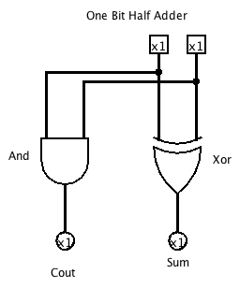

**Part 2- One Bit Full Adder**

1)

|  |  |  |  |  |
| --- | --- | --- | --- | --- |
| **A** | **B** | **Carry in (Cin)** | **Sum** | **Cout** |
| 0 | 0 | 0 | 0 | 0 |
| 0 | 0 | 1 | 1 | 0 |
| 0 | 1 | 0 | 1 | 0 |
| 0 | 1 | 1 | 0 | 1 |
| 1 | 0 | 0 | 1 | 0 |
| 1 | 0 | 1 | 0 | 1 |
| 1 | 1 | 0 | 0 | 1 |
| 1 | 1 | 1 | 1 | 1 |

2)

Sum= !A•!B•C + !A•B•!C + A•!B•!C + A•B•C

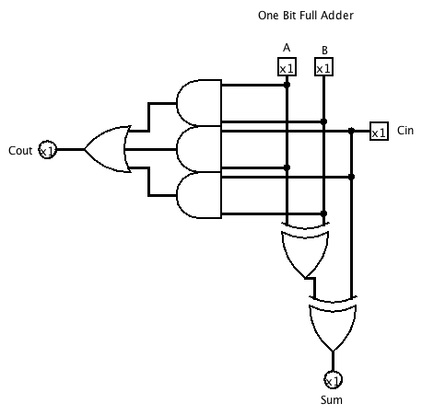Cout= A•B + A•C + B•C

3)

**Part 3- 4-bit Adder**

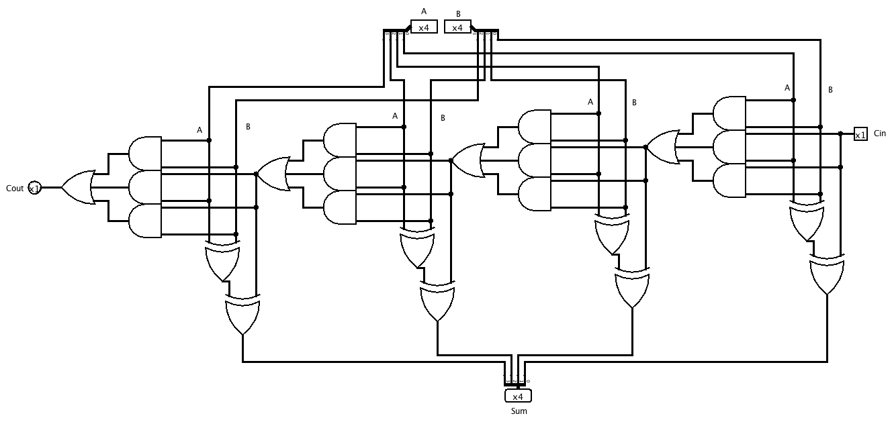

**Part 4- Logisim 4-bit Adder**

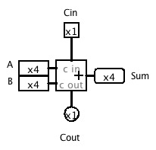

**Questions about a 4-bit Adder**

Answer the following question about a 4-bit adder without consulting your circuit. Unless otherwise indicated, give your numerical answers in decimal. After you have filled out the chart, use your 4-bit adder to check your answers. Make sure you understand and can calculate all the answers correctly.

1. What is the range of unsigned numbers that you can represent in 4 bits?

We can represent 0 through 15.

2. Fill out the following table of sums, carry, and borrow that your 4-bit adder circuit will give. Assume unsigned representation of numbers in 4 bits.

Binary Binary Binary Decimal Decimal Decimal

A input B input sum A input B input Sum Carry (0 or 1)

------- ------- --- ------- ------- --- -----

0000 0111 0111 0 7 7 0

1100 0101 0001 12 5 17 1

0101 0101 1010 5 5 10 0

1111 1111 1110 15 15 30 1

0010 0110 1000 2 6 8 0

3. Assuming unsigned 4-bit representation of numbers, under what conditions does adding produce a result that is not meaningful with respect to normal addition and the constraint of only 4 bits to hold the sum?

A 4-bit adder will result in non meaningful answers when you add two numbers that yield an answer greater than 15. This is because a 4-bit adder can only output up to the number 15. After 15, we start to get a Carry out.

4. What does the carry out pin signify?

The Carry out pin signifies the next bit place after what can be displayed. EX| the result 17 will be displayed as 0001 with a Cout of 1, since 1710 = 100012

5. Assuming unsigned 4-bit representation of numbers, what does your 4-bit adder produce if you try to add two numbers whose sum exceeds the 4-bit range of values? Give an arithmetic expression for the unsigned value of the sum bits in terms of x and y input values (use mod; if you don't know what mod is, then hold this question until later).

If you try to add two numbers whose sum exceeds the 4-bit range it starts to roll over again from the beginning and carrying out a remainder.

|  |  |  |  |
| --- | --- | --- | --- |
| Sum | |  |  |
| Binary | Decimal | What’s Displayed | Carry out(Cout) |
| 1110 | 14 | 1110 | 0 |
| 1111 | 15 | 1111 | 0 |
| 0000 | 16 | 0 | 1 |
| 0001 | 17 | 1 | 1 |
| 0011 | 18 | 10 | 1 |

Can use the expression $f\left(x,y\right)=x+y (mod16)$